**Term Project Report ESC113M**

**Group-2**

**Team Members,**

1. **C Zoliansangi, 220303**
2. **Sanskaar Srivastava, 220967**
3. **Abhishek Maurya ,220047**
4. **Adarsh Pal,220054**
5. **Anushri Bhargava,220189**
6. **Kaushalendra Singh, 220511**
   1. **Problem Statement**

The reaction to produce Nitrogen Dioxide (NO2­)has been well established as a third-order homogeneous reaction. This gas-phase oxidation, has two steps :

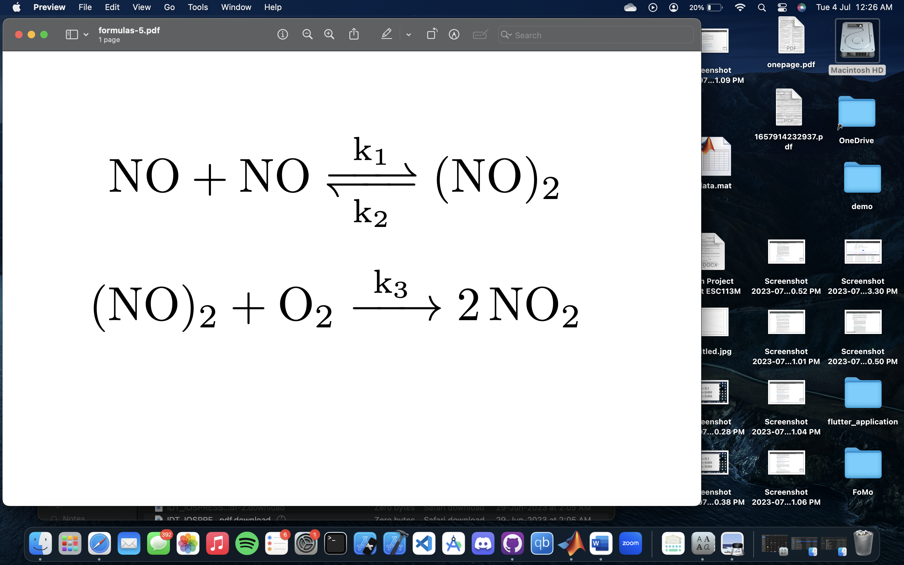

This reaction, like most third-order reactions, is not termolecular but rather a combination of an equilibrium followed by a subsequent bimolecular step.

Our objective is to use different computational and numerical methods to solve real life-problems related to the field of Chemical Engineering, and to understand the differences between different computational methods when categorized on the basis of their accuracy and error.

* 1. **The Kinetics**

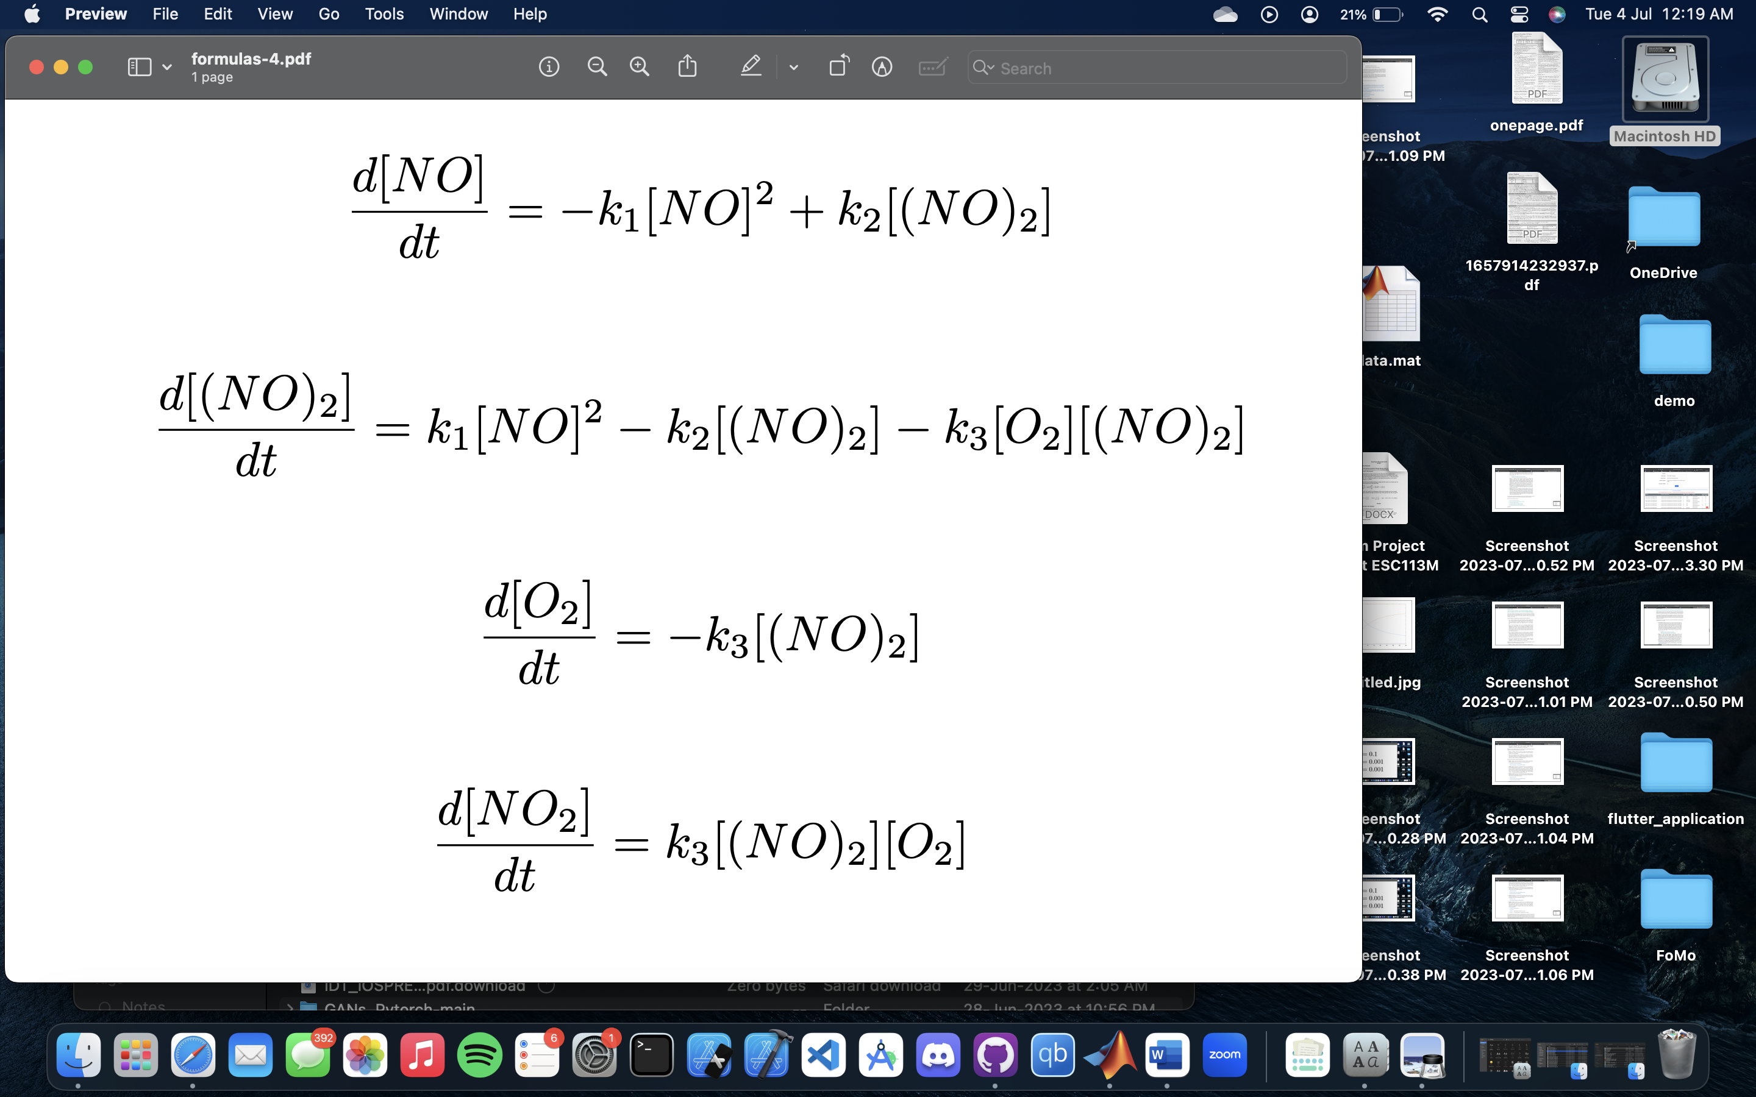

* 1. **Assumptions**

Though the first step of the reaction (Formation of (NO)2) is a very fast process we assume it to be of a significantly observable pace in this hypothetical system to ease our analysis and to achieve a more efficient solution.

The rate constants are taken as,

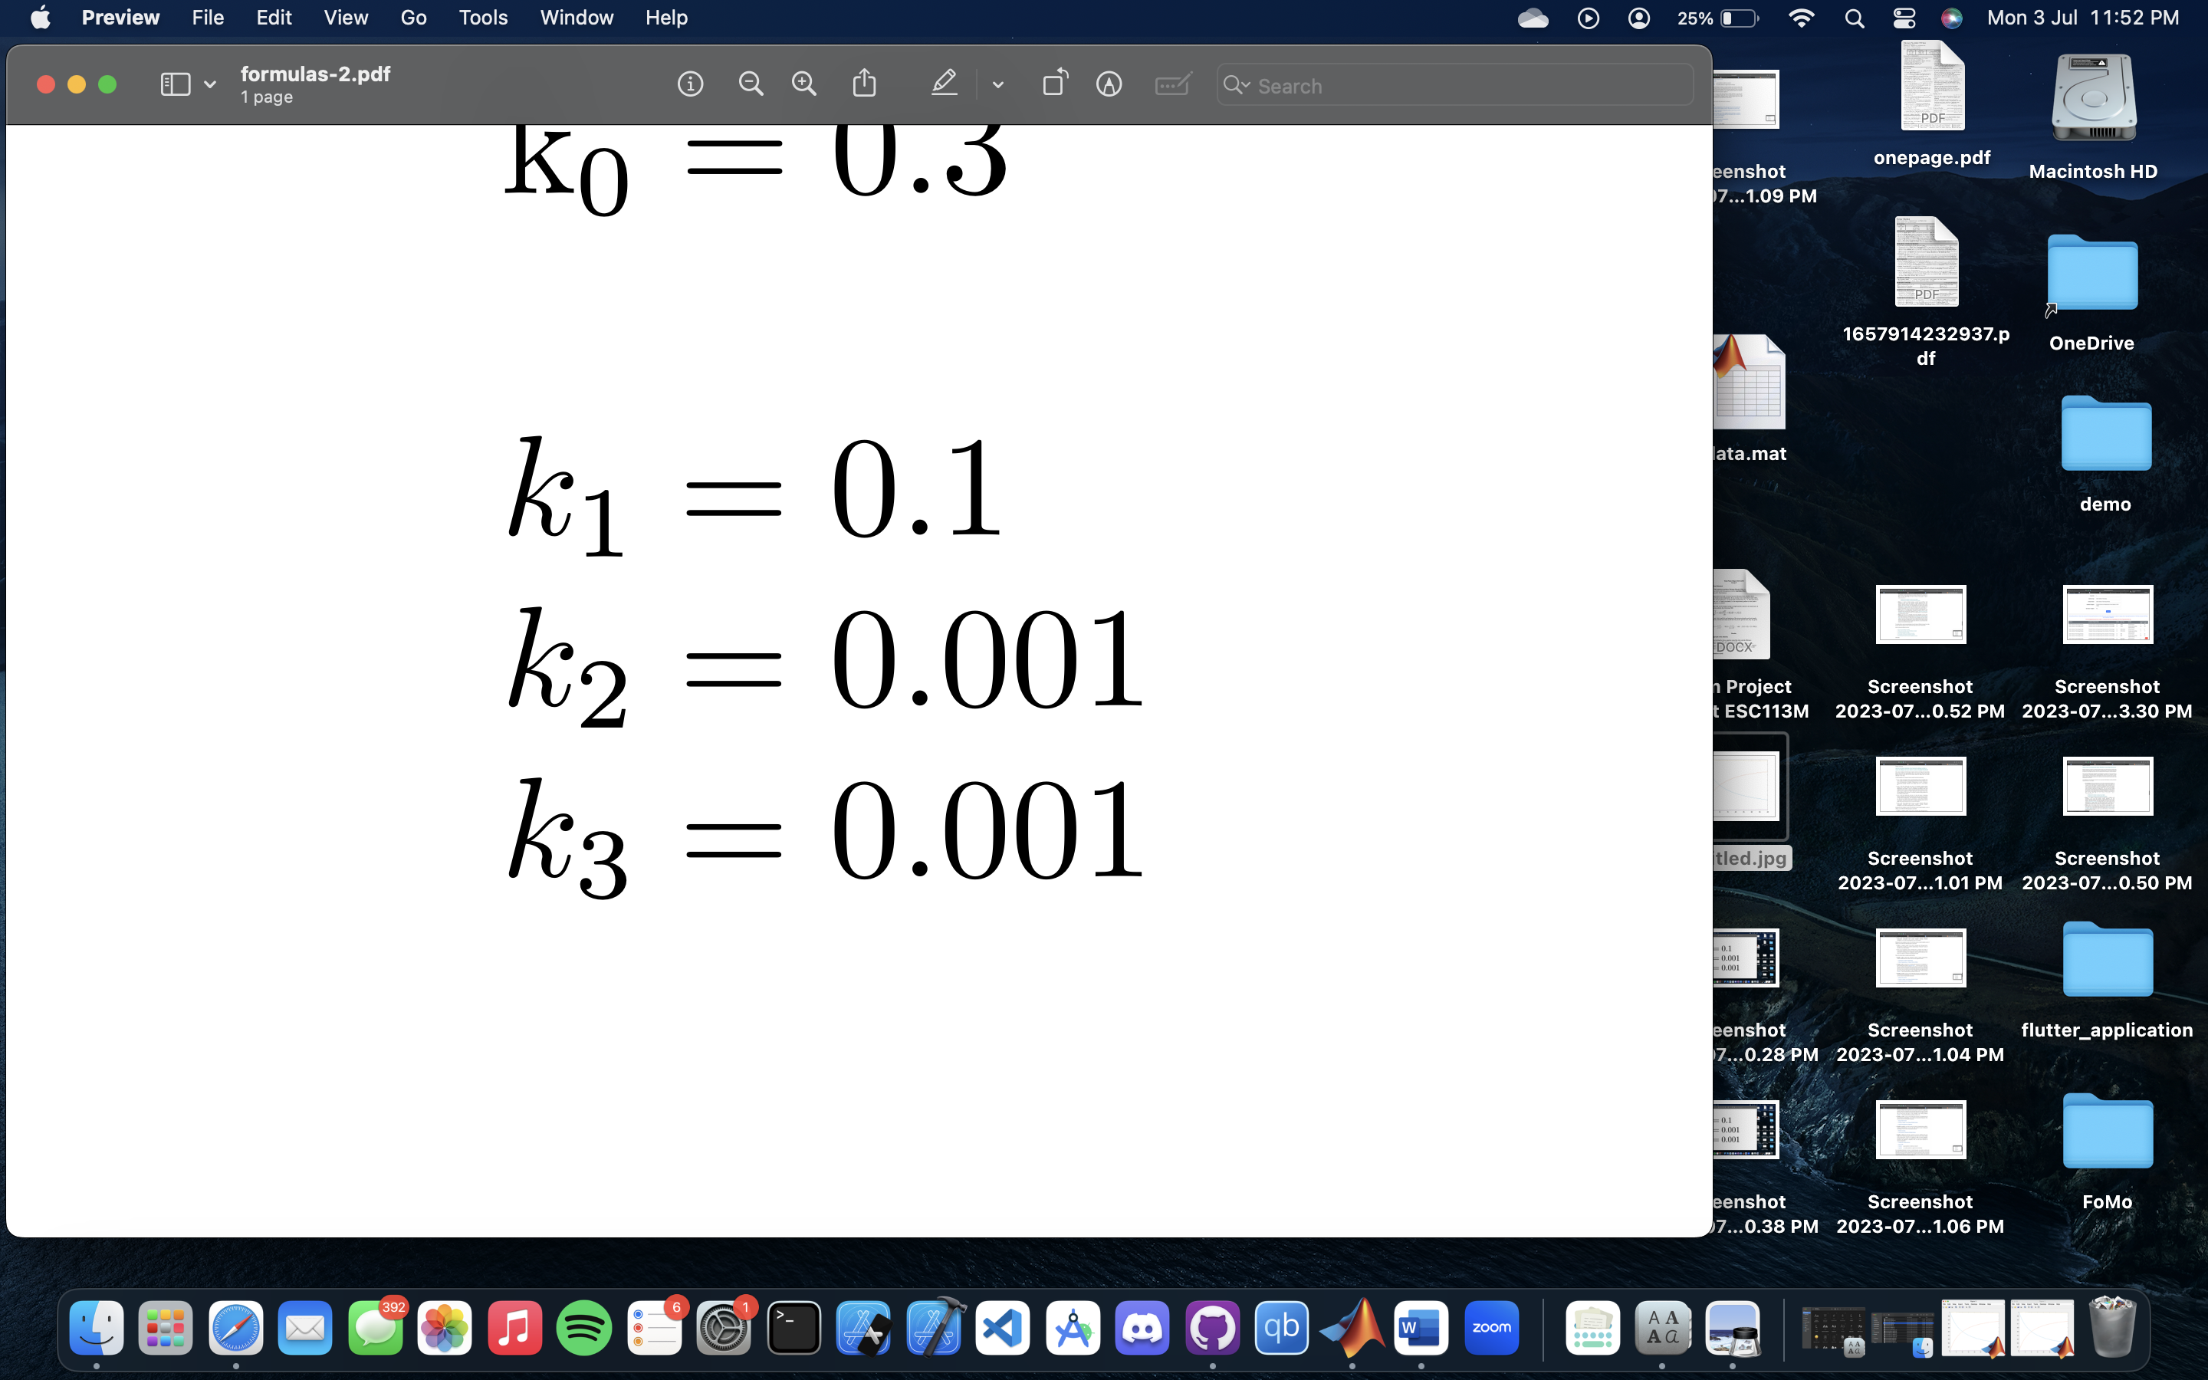

The initial concentration of the compounds are taken as,



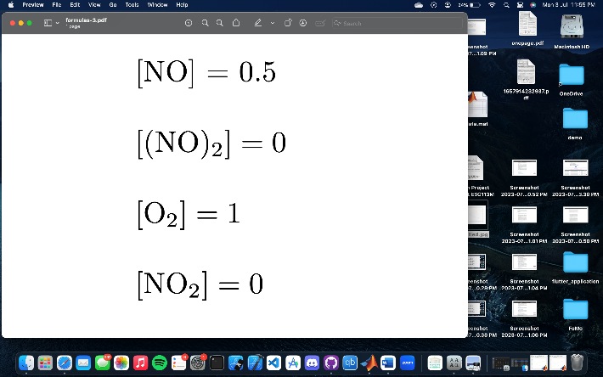­



* 1. **Explicit Euler Method.**

We assume that the reaction is 40 seconds long and our **step size is 0.1 seconds.**



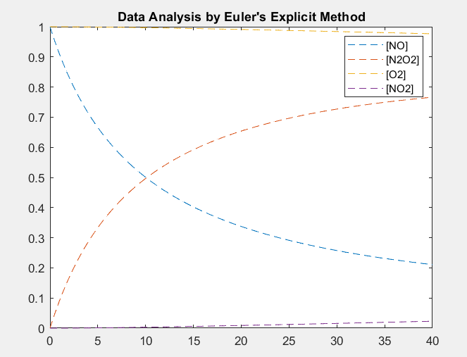

* 1. **Predictor Corrector Method**

We assume that the reaction is 40 seconds long and our **step size is 0.1 seconds.**

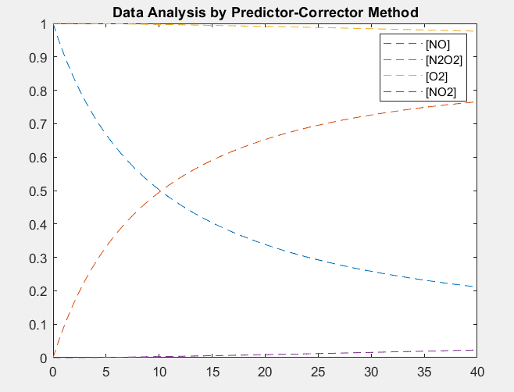

* 1. **Fourth-Order Runge Kutta Method (RK4)**

We assume that the reaction is 40 seconds long and our **step size is 0.1 seconds.**

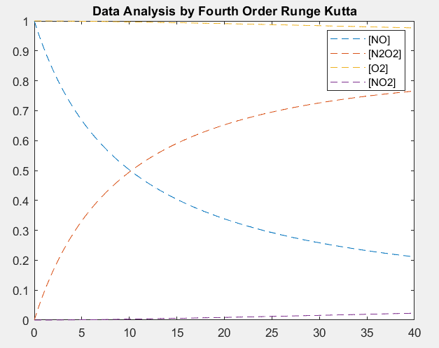

**7 Conclusion**

Theoretically, it is mentioned that the ***Fourth-Order Runge Kutta*** Method

Than the other two methods. Hence to Check the Accuracy of the other two methods we treated the **Runge Kutta** Method as the most accurate threshold, and in comparison to that we figured out which method was more accurate amongst the rest two we applied.

**8 Result**

In order to estimate accuracy of the methods we used the approximate time of 10th second of the reaction and created a vector of the concentrations of the components at that time by different methods. And In calculating the error between theses vectors we used the "**computenorm"** function which gave us the following data.

*Error(Concentration(Explicit)-Concentration(RK4))*=**0.0010**

*Error(Concentration(Predictor-Corrector)-Concentration(RK4))*= **5.0454e-06**

Hence In our computational analysis of the three methods we found out that In terms of accuracy:-

***Fourth Order Runge Kutta>Predictor-Corrector>Euler's Explicit Method***